Parish Staff
Pastor Nathan Wicks
Office Hours;
Wednesday 10-1
Thursday 10-12
Subject to change based on availability

Administrative Assistant:
Darcy Wemark
(563)-737-2380
ridgewayparish@gmail.com

Parish Treasurer:
Krista Baldauf
507-440-7343

Address:
Ridgeway Lutheran Parish
PO Box 2
Ridgeway, IA 52165

Website:
Ridgewayparish.weebly.com

Facebook:
Ridgeway Lutheran Parish
May 2024
Living Scripture
Someone asked recently, after hearing that the earliest parts of the New Testament weren’t written down until 20-30 years after Jesus died, what the Bible was like for early Christians? Well, scripture was still the Hebrew scripture, or the ‘Old Testament,’ but the news that Jesus had risen from the dead influenced everything that scripture meant to believers. Jesus had risen, and one of the first things he did for people in his resurrection appearances was, ‘…beginning with Moses and all the prophets, he interpreted to them the things about himself in all the scriptures’ (Luke 24:27). The meaning of scripture had been fulfilled in his death and resurrection, and trying to understand and share this good news was the task of the newly formed community who confessed that ‘Jesus is risen indeed!’ And so an answer to this question about what scripture was like before the New Testament was written down is that scripture was lived in the community. Scripture was lived before it was written, by the community who ‘…devoted themselves to the apostles’ teaching and fellowship, to the breaking of bread and the prayers’ (Acts 2:42).
In the season of Easter the first reading in worship, instead of coming from the Old Testament, comes from the book of Acts. Acts describes the action of the first apostles as they preached and taught and healed much like Jesus had before them, as they lived with new power with the coming of the Holy Spirit after Jesus’s resurrection and ascension. The use of Acts in the place of the Old Testament for worship reflects the continuity of God’s word working in community before and after Jesus’s resurrection, and that somehow this word with which the whole world was made (Genesis 1), which was embodied especially in Jesus Christ (John 1), is alive and at work in new ways in Christian community. Jesus told the disciples that they were ‘witnesses’ (Luke 24:48), which is not a word for a passive observer, but it means they are actively involved in sharing the meaning of Jesus’s resurrection, of bearing the witness of this good news for all people. It means they are a part of God’s word, they are characters in God’s ongoing story of life and mercy in Jesus’s name just as much as Moses and Sarah and Ruth and Isaiah were.
The use of scripture in this early Christian community before it was written down still shows us what the purpose of the scripture is: it’s meant to be lived. At the end of John’s gospel he said, “(This is) written so that you may come to believe that Jesus is the Messiah, the Son of God, and that through believing you may have life in his name” (John 20:31). Faith in Christ is not just something that happens long ago, but it is for ‘life,’ it is lived in communities that gather to actively bear witness that he is risen, that break bread and see Jesus, actively present, in the community that has become his body. This story of God’s life for us is still happening, and our purpose as the church is to become woven into this story, and share it until all may glimpse the salvation offered for all people in the name of Jesus, the risen Lord. Then God’s story will reach it's true ending which, as we say in the Lord’s prayer, will be ‘forever and ever, Amen.’ Peace in Christ,
Pastor Nathan Wicks

PARISH NEWS
May Worship Schedule
May 5 – 9 AM Orleans/HC; 9:45 GIFT (M); 10:30 Madison/HC
10 AM- GIFT kids serving up a taco “Fiesta for Mom’s (O), All are welcome!
May 12 – 9 AM Orleans/HC; 10:30 Peace/HC
May 19 – 9 AM Orleans/HC; 10:30 Madison/HC & Baptism
May 26 – 9 AM Orleans/HC; 10:30 Peace/HC
We Keep In Our Prayers;
Please continue to hold all those in need of healing in our prayers for: Carl Bergan, Patty Hovden, Wayne Hovden, Arlin Midthus and Kayla Timp.

The Parish extends sympathies and prayers to the family of Gary Ryant. Gary’s funeral was held April 8th at St. Wenceslaus Catholic Church in Spillville. Gary’s wife, Jane and daughter, Chezny are members at Peace.

The Parish extends its sympathies to the family and friends of Lavonne Enderson, member of Peace, who passed away on April 14th.

(If you know of someone that is in need of our prayers, please let the Parish Office know: 563-737-2380 or email: ridgewayparish@gmail.com)

CONGRATULATIONS are extended to Stuart & Stephanie Bessler and family on the birth of their daughter Maisie Marilyn Bessler. Maisie was born March 28th, weighing 8 lbs., 9 oz. and was 20 ¼ inches long. May God bless you all!
WELCOME to our new members at Madison;
Gary Holstad, John Anderson, Rodney, Jane & Jenna Dotzler, Tanner & Daiton Johnson,
Gerad, Denise & Dalen Voltmer, Kolin, Kasey & Keatyn Krauskopf
WELCOME to our new member at Orleans; Laura Miller
​ God has granted us so many gifts and we are excited for the opportunity to share God's word with you!

TAKE THE CAKE! Parish youth have made 14 kits to take to the C3 Ministry Event (Synod Gathering) in June to be donated to food pantries in Northeast Iowa. Thanks to the donations we have received so far. You can help us make more by donating the following items; cake mixes, cans of frosting, sprinkles, birthday candles & rectangle foil pans with lids! Balloons & streamers are welcome as well! Please place donations on the tables where the bulletins are located at each church for pick-up.
Our Ministry of Christian Education
GIFT (Growing in Faith Together)
All youth preschool and older are welcome to attend the program that works best in your schedule! High school helpers & adults are also welcome!
Wednesday Night GIFT
Classes will resume in September!

Sunday GIFT at Madison
Last class for the school year, Sunday, May 5th
9:45 AM

You’re Invited To
Summer 2024 Vacation Bible School
Save The Dates! Monday July 22nd-Thursday July 25th
6:00-7:45 PM At Peace Church in Ridgeway
Family Program & Fun Night Thursday July 25th!

The Ridgeway Lutheran Parish (Madison, Peace & Orleans Churches) invite all children finishing preschool-6th grade to our Vacation Bible School this summer.
Please register with the link on our “Ridgeway Vacation Bible School” Facebook page, email us at (ridgewayvbs@gmail.com) or contact our VBS coordinator-Jenny Larson at (641) 228-0020 to register today!
Volunteers (7th Grade & Older) are needed to help run small groups. Let Jenny know if you or someone you know are interested in helping.
6th-12th Grade Youth Group
(Generally Meets the 4th Wednesday of the Month)
With the last days of school the end of May and summer sports in full swing, the youth group will not meet in May.
Congratulations to the Parish 2024 Confirmands
Josephine Delores Knutson
Josie is the daughter of Michael & Tara Knutson and a member at Madison!
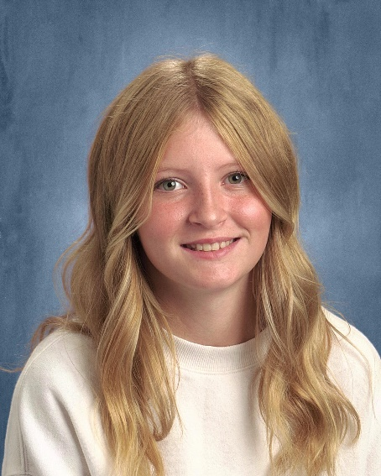
Sponsor Names: Brandon & Michelle Stille, Kaitlyn Moellers
Bible Verse: John 8:12 “I am the light of the world. Whoever follows me will never walk in darkness, but have the light of life.”

Favorite Food: Mashed Potatoes
Favorite Hobby: Volleyball
Favorite Church Memory: 2023 VBS tie dying with all the kids

Nathan Grant Iverson
Nathan is the son of Larry & Crystal Iverson and is a member at Orleans!
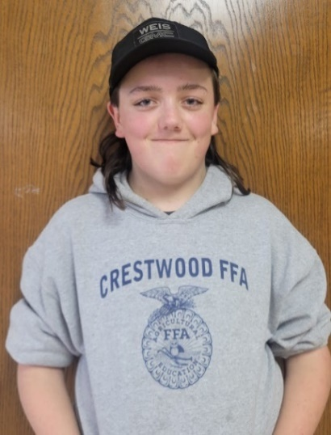
Sponsor Names: Ana Olson Johnson, John Iverson
Bible Verse: John 3:16 “For God so loved the world that he gave his only Son, so that everyone who believes in him may not perish but may have eternal life.”
Favorite Food: Pizza & Boneless Wings
Favorite Hobby: Restoring John Deere Lawn Tractors
Favorite Church Memory: Covering my ears when BJ started playing her trumpet!
Kyle Brian Bronner
Kyle is the son of Paul Bronner & Rhonda Bronner & is a member at Peace!
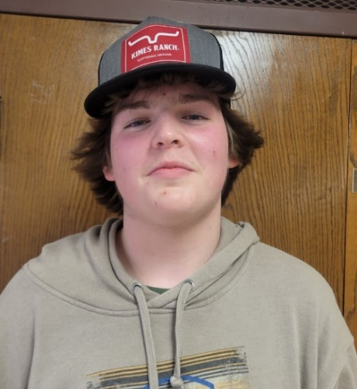
Sponsors: Rita Faber, Margaret Bronner
Bible Verse: Ephesians 2:8-9 “For by grace you have been saved through faith, and this is not your own doing; it is the gift of God—not the result of works, so that no one may boast.”
Favorite Food: Tacos
Favorite Hobby: Trapshooting
Favorite Church Memory: Playing Nerf war in the Madison church basement

Abe Harris Wemark
Abe is the son of Nick Wemark and Katie Croatt & is a member at Peace!
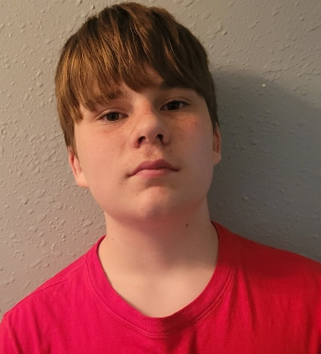
Sponsors: Eric & Darcy Wemark, Gina Croatt
Bible Verse: Philippians 4:13 “I can do all things through him who strengthens me.”
Favorite Food: Steak
Favorite Hobby: Golfing
Favorite Church Memory: First Communion
COUNCIL MEETINGS
Parish Council Meeting: Tuesday, May 21st 6 PM at Orleans
MOP Council Meetings: Tuesday, May 21st 7 PM at Orleans
*Minutes from each council meeting can be found in manila folders at each church. *
WELCA PARISH ACTIVITIES
Women of the Evangelical Lutheran Church meetings are open to all women of the parish & community.
- Monday, May 13th 1:00 WELCA Meeting & Bible Study at Peace Church
- Tuesday, May 14th 1:30 Miriam Circle at Caryl Larson’s home

STEWARDSHIP
March Monthly Budgeted Expenses Offerings
Madison $ 7,136.00 $ 2.380.00
Orleans $ 5,669.00 $ 2.085.00
Peace $ 6,391.00 $ 4,565.00
Thank you for your commitment to your church & this parish!

The deadline to have something included for the June Newsletter is May 23rd.

Northeastern Iowa Synod Strengthens Community Through Congregation Mission Support
Congregations of the Northeastern Iowa Synod, including those of the Ridgeway Lutheran Parish, participate in and contribute to God’s work in the world and at home through Mission Support. Generosity to Mission Support – the offerings that ELCA congregations share with synods and the churchwide organization — supports new ELCA ministries and partnerships around the globe and provides funds for staff and resources to carry out local ministries in the Northeastern Iowa Synod.
Please take a moment to reflect on how Ridgeway Lutheran Parish and this synod are making a difference together through a spirit of generosity, love of God and love for our neighbor:
- The Northeastern Iowa Synod celebrated the installation of 16 pastors in 21 congregations in 2023, enriching our synod's communities with new spiritual leadership and vitality.
- This synod directly supports rostered ministers through the annual Fall Theological Conference, Day of Renewal, and safe ministry education. In addition, our Bishop and synod staff members provide pastoral care and guidance to ministers and congregations facing challenging circumstances.
- Our synod networks build connections in our communities to care for our environment, stand up for racial justice and fight hunger to make our corner of Iowa a better place.

Thank you for your faithful partnership and support with the Northeastern Iowa Synod! We are 143 congregations, one synodically authorized worshiping community, two Lutheran colleges (Luther and Wartburg), one campus ministry (Three House, UNI), two Bible camps (EWALU and Riverside), one seminary (Wartburg) and Lutheran Social Services (providing care for some of the most vulnerable among us).
You are part of all of this ministry, and God is doing great things through you!
-- Pastor Liz Bell, Assistant to the Bishop in the Northeastern Iowa Synod

COMMUNITY EVENTS & ANNOUNCEMENTS
- Thursday, May 2nd, at 5:00-6:15 PM Decorah Community Free Meal, at Decorah Lutheran Church. This month we are hosted by members of the Decorah Lions Club who will provide volunteers, salads, and desserts. The main course is provided by Sodexo of Luther College.
- Sunday, May 5th 11 AM-1 PM “Laura’s Sack Lunch,” Drive Thru Meal, Burr Oak Lutheran Church Parking Lot, Winneshiek Co. Cattlemen’s Serving Ribeye Steak Sandwiches & Cheeseburgers, proceeds towards restoring the Burr Oak Mercantile
- Monday, May 27th 10 AM American Legion Post- Spillville, Memorial Service at Veteran’s Memorial in Ridgeway (weather permitting)
- 4th Annual We're on a Mission...Pave the Way 5K Fun Run/Walk, Saturday, June 1. This event is a fundraiser for the Calmar Lutheran Church Property Improvements, and the upcoming youth mission trip to Nashville. Food collected will be given to the Little Food Pantry.
  - Starts and Ends at the Calmar Lutheran Church
  - 8:00 a.m. to 8:25 a.m. Registration
  - 8:30 a.m. Race starts
  - $30 entry fee plus a food item for the Little Food Pantry
  - Registration forms can be found on the church website or the church Facebook page

Turkey River Culture Center Music Schedule Spring 2024
- Acoustic Jam May 3rd, May 25th, June 7th, June 22nd
- Beginner’s Slow Jam 11 AM-12, May 3rd, May 25th, June 7th, June 22nd

May 2024 – Give a Gift to LSI: Support Mothers across Iowa
Mother’s Day is Sunday, May 12. Did you know LSI brings hope and healing to mothers in each of our service lines? Here are just a few examples:
The Child Care Business Development program in our Immigrant and Refugee Community Services prepares women, often mothers, to run an in-home childcare business. This small business opportunity allows them to provide for their family and ensure their children receive culturally appropriate care.
Many mothers benefit from our Foster Care and Adoption services, whether they be mothers who are blessed with a child through adoption or foster mothers who provide love and guidance to children from all paths of life. Early Childhood Services prepares mothers-to-be for birth and raising a child. Additionally, home visitation programs help ensure a strong support system for young parents across the state.
These are just three examples of how LSI serves mothers in Iowa. This Mother’s Day, we encourage you to give a gift in honor of your mother or motherly figure to ensure mothers around the state receive the care and support they deserve.
Donate online at lsiowa.org/donate or send a check to Lutheran Services in Iowa, PO Box 848, Waverly, IA 50677-0848.
Our Mission: Lutheran Services in Iowa responds to the love of Jesus Christ through compassionate service. LSI is an affiliated social ministry partner of the Iowa congregations of the ELCA (Evangelical Lutheran Church in America) and a member of LSA (Lutheran Services in America). We proudly serve people of all ages, abilities, religions, sexes, gender identities, national origins, ethnicities, races, and sexual orientations. Learn more at LSIowa.org and facebook.com/LSI.iowa.

